**DAILY ONLINE ACTIVITIES SUMMARY**

|  |  |  |  |  |  |  |  |  |
| --- | --- | --- | --- | --- | --- | --- | --- | --- |
| **Date:** | **17-6-2020** | | | | | **Name:** | **Pavana P** | |
| **Sem & Sec** | **6A** | | | | | **USN:** | **4AL17CS057** | |
| **Online Test Summary** | | | | | | | | |
| **Subject** | | **C programming quiz** | | | | | | |
| **Max. Marks** | | **15** | | **Score** | | | **11** | |
| **Certification Course Summary** | | | | | | | | |
| **Course** | **Workshop Exercise Solving.** | | | | | | | |
| **Certificate Provider** | | |  | | **Duration** | | |  |
| **Coding Challenges** | | | | | | | | |
| **Problem Statement:**  1.Find the smallest positive integer value that cannot be represented as sum of any subset of a given array sorted in ascending order  2. Write a Java program to find the row, column position of a specified number (row, column position) in a given 2-dimensional array | | | | | | | | |
| **Status: Completed** | | | | | | | | |
| **Uploaded the report in Github** | | | | | **YES** | | | |
| **If yes Repository name** | | | | | **DAILY STATUS** | | | |
| **Uploaded the report in slack** | | | | | **YES** | | | |

.

**Workshop and Quiz**

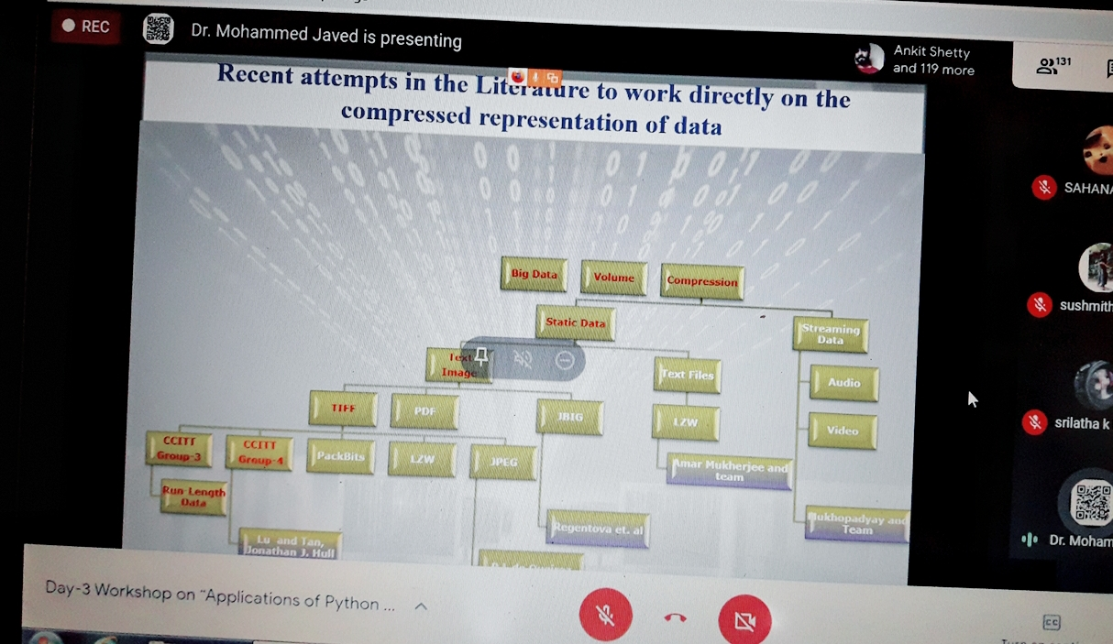

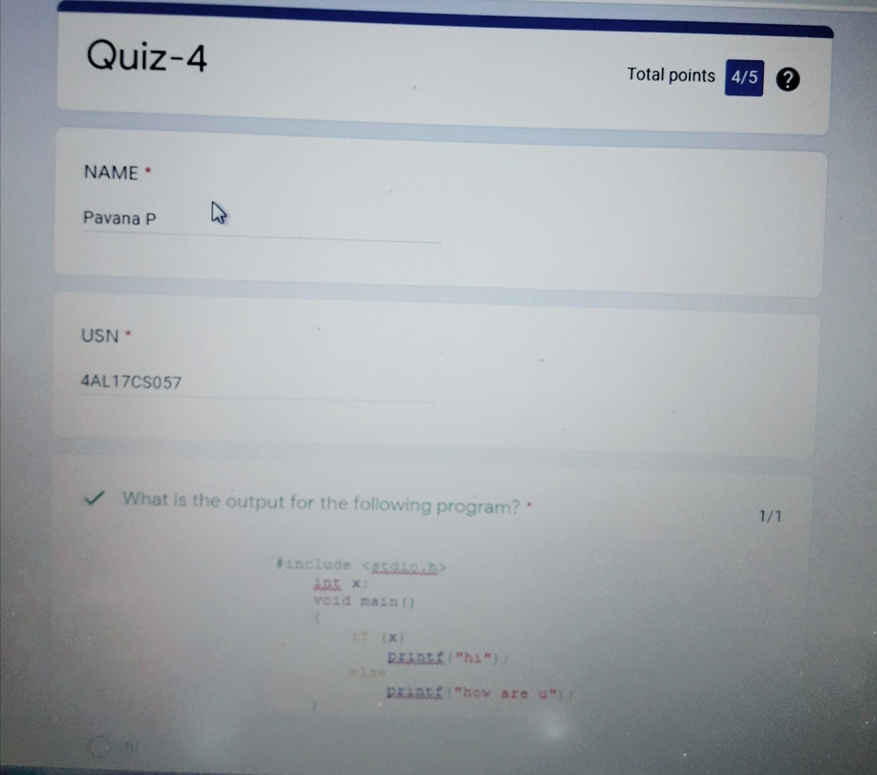

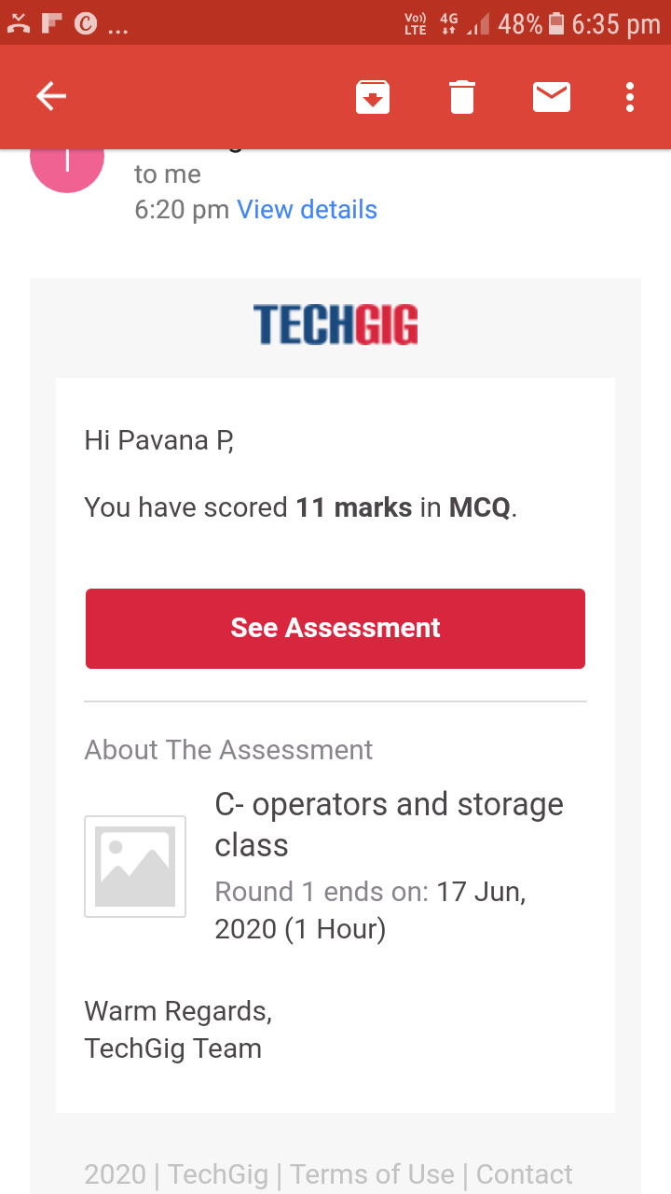

**Workshop Exercise Details:**

<https://github.com/pavana-p-kulal/Applications-of-Python-Programming-in-DA-and-ML>

.**Coding Challenges Details:**

**https://github.com/pavana-p-kulal/DAILY-STATUS/tree/master/17-6-20/Online%20Coding**